RUSTIN FOOTBALL BOOSTER CLUB

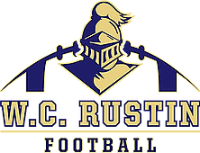
On behalf of the Rustin Football Booster Club, we welcome you to become a part of our successful Football Program at Bayard Rustin High School. The team will commence its 16th season this Fall, and we are looking for sponsors for our Axe Throwing social in August. All monies raised in this fundraiser will go directly back into our football program and help support the players during the season.
Your company logo will prominently be displayed in a throwing lane, appear on our web page, and announced twice during our home games.
Go Knights!
Please complete the following information:
Business Name:
Contact Person:
Email:
Phone:

Please choose one of the following:
I would like to sponsor a lane: Cost: $150

PAYMENTS:
*Please make checks payable to:
Rustin Football Boosters
c/o Kim Authement
1007 Regimental Drive, West Chester, PA 19382

*Payment can also be made via PayPal: https://paypal.me/RustinFootball?locale.x=en_US or
*Venmo: @RustinFootballBoosters (Please indicate Axe Throwing in in the Note)

