RUSTIN FOOTBALL BOOSTER CLUB

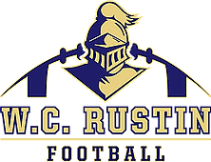
On behalf of the Rustin Football Booster Club, we welcome you to become a part of our successful Football Program at Bayard Rustin High School. The team will commence its 16th season this Fall, and we are looking for sponsors to purchase/renew stadium signs for 2022.
Stadium signs will be displayed along the fence of the multi-sport field and visible to attendees of all sporting events throughout the fall season, which runs from late summer through early winter. Your purchase/renewal will help by allowing our team to secure all the necessary tools for training and also lower the cost of various items needed to support our players. This also provides a terrific opportunity for your company to advertise to the community.
Thank you for your support, it is greatly appreciated.
Go Knights!
Please complete the following information:
Business Name:
Contact Person:
Email:
Phone:

Please choose one of the following:
I would like to purchase a 5x3 sign for 2022 season. Cost: $500

I would like to renew my company sign for 2022 season. Cost: $250
PAYMENTS:
*Please make checks payable to:
Rustin Football Boosters
c/o Monique Corrigan
412 Leslie Lane, West Chester, PA 19382

*Payment can also be made via PayPal: https://paypal.me/RustinFootball?locale.x=en_US or
*Venmo: @RustinFootballBoosters (Please indicate STADIUM SIGN in in the Note)

